**CURRICULUM VITAE**

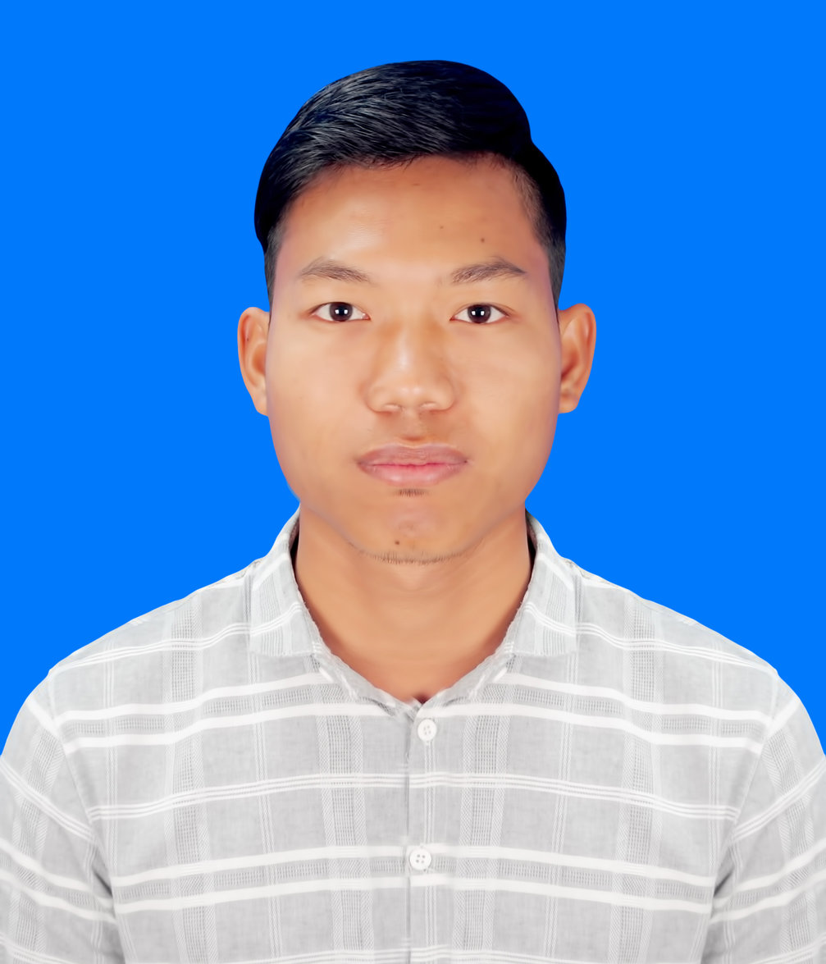

**Chan Myae Linn**

**Email : chanmyaelinn.alk@gmail.com**

**Phone : 09-428274039,09-989499109**

**Address : 37th street, between 76th and 77th street, Mandalay.**

**HIGHTLIGHT OF PERSONAL QUALIFICATION**

* +5 years’ experiences in EHO/CSO health system strengthening and community development projects
* Highly effective leading and have extensive knowledge in project management and M&E system
* Ability to work independently and strong interpersonal communication and presentation skills

**PERSONAL PROFILE**

Name : Htet Wai Yan

Age : 28 Years

NRC No : 5/Ma Ma Ta (N)068019

Date of birth : September 5, 1992

Father’s Name : U Kyaw San Yin

Gender : Male

Race and Nationality: Burmese and Myanmar

Marital status : Married

**EDUCATION QUALIFICATION**

* **B.Comm.H** (Bachelor of Community Health), University of Community Health, Magway (2009-2013)

I attended the following training;

* Project Cycle Mangement and M&E training
* QGIS training
* Data Analysis with Mysql
* Mobile Data collection Tool
* Web Application Development
* C# Programming for destop application
* Ethnic diversity and social inclusion
* Safety and security risk management training
* Men Engagement Training
* AEI and CS training
* Universal Health Coverage Training
* Pharmacy training
* Leadership and Management Training
* **Language skills –** Four skills in English (Good), Myanmar (Mother language)
* **Social Intelligence –** Strong interpersonal communication skill and presentation skills, ability to speak in the public campaign and communicate with multi-diverse groups and well understanding of different ethnic cultures and societies, able to work under stressful conditions and working environment

* **Technical Skills –** Extensive experiences in computer especially in data collection, data analysis & Microsoft package

**PROFESSIONAL WORKING EXPERIENCES**

**Project -MNCH & Health System Strengthening(ACCESS To HEALTH)**

**Position - Senior Health Program Officer**

**Organization -Relief International**

**Location -Laihka and Mongkaing Townships, Southern Shan State**

**Period -1st January 2019 to 6th March 2020**

**Key role and responsibilities**

* Responsible for the implementation and strengthening of partner Organizations( MOHS, EHOs, and CBOs).
* Project Cycel Management and M&E capacity building trainings to EHOs ,CSOs and partners.
* Participate in M&E framework development relating to ACCESS To Health MNCH program
* Reviewing MNCH program framework of EHOs , CSOs.
* Development of MNCH logframes, workplans, monitoring tools with M&E Manager & Project Manager.
* Collect and compile project data regularly to submit to Project Manager and M&E Manager including case studies , community assessement and focus group discussions.
* Mapping of health facilities (EHOs , THD) and updated regularly.
* Perform regular (quarterly) program inputs, outputs and outcome progress reports with M&E Manager.
* Self-developed questionnaires for some electronic data collection with ODK, Kobo and analysis on excel.
* Review and supervise for pre and post data verification of M&E Assistant reports.
* Responsible to assist the M&E Manager for donor reporting and integration of MNCH database to country health program database system.

**Project -MNCH & Health System Strengthening(ACCESS To HEALTH)**

**Position - Project Officer**

**Organization - Relief International**

**Location - Laihka Township, Southern Shan State**

**Period - 26th June 2017 to 31st Dec 2019**

* **Technical and close supervision with community health promoters in project implementation**

**-**To ensure effective management, actives planning, technical supporting to community health promoters

**-**Supervision on community health promoters

**-**Management on human resources community health promoters by supporting of direct supervisor

* **Responsible on implementation in health system strengthening at targeted areas**

-Supervision on joint activities implementation with THD and Ethnic Health Organization

-Facilitate coordination meetings, advocacy meetings and awareness raising sessions at the community level together with community health promoters

-Facilitate in training for BHS and VHW conducted at Township level

* **Responsible of strengthening partners who are working together on 3MDG-MCH at targeted areas**

-Responsible for close collaboration with partners for implementation of the project

-Conducted monthly meeting with partners in regular schedule basic

-Technical supporting to partners in regular schedule basic

-Joint supervision and monitoring planning with partners

-Working closely with Project Health Coordinator on partner approach sustainability

* **Responsible on strengthening of health volunteers network for 3MDG-MCH project at Shan**

-Work closely with township health staffs from the rural health center and sub-rural health center levels to implement CTHP activities

-Mapping of health facilities and health volunteers (THD/EHO) and updating on regular basic

-Assist Township Health department to follow up on existing and newly trained volunteer health workers regularly

-Organizing FGD in community level and action points are planned together with Field Health Coordinator

-Awareness of feedback mechanism of health care providers, health services and also from the community

-Regular schedules planning to health volunteers for technical support

* **Responsible for reporting and activities planning according to reporting guidelines**

-Assist Project Health Coordinator to prepare project teams weekly and monthly work palns

-Participate in conducting situational analysis and other M&E activities

-Cross checking data and feed backs with M&E team (eg, referral support ,HMIS, etc)

-Provide support to township health department and logistic assistants to regularly update on inventory of medical and non-medical items supported by the project.

* **Representative of Relief International for networking and coordination with INGO/LNGO, CBOs,CSOs and other community actors.**

-Coordinate with key stakeholders from differents community-based organization and ethnic groups

-Attend external meeting when /if assigned to represent RI

**Project - TB, Malaria and MNCH**

**Position - Project Officer**

**Organization - CESVI**

**Location - Namhsan Township, Northern Shan State**

**Period - 1st November 2015 to 23rd June 2017**

**Key role and responsibilities**

* Management and assigned work plan for Community mobilizers
* Technical oversight on community mobilizers for high program implementing
* Coordination and cooperation with key stakeholders and Local CSO
* Supervision and monitoring of Community mobilizers and BHS Outreach activities
* Pre and post verification of reports from Community mobilizers
* Monthly programmatic reports MNCH, TB and Malaria to Project Manager
* Monthly Narrative report to Project Manager or Project Local Coordinator
* Checking and verification of VHVs reports
* Monthly reporting for TB and quarterly reports for malaria (NMCP) to respective line supervisors

**Project : Stop TB Fight TB Together Project**

**Position : Township Project Supervisor**

**Organization : MHAA**

**Location : Pale Township, Sagaing Region**

**Duration : 1st January 2014 to30th September 2015**

**Key role and responsibilities**

-Conducted monthly coordination meetings with volunteers.

-Regular Monitoring and Supportive Supervision visit to villages.

-Participated in a community awareness-raising campaign.

-Monthly health education sessions.

-Assisted supervisor for donor reports.

**Referees**

1. **U Han Min Naing**

**M&E Manager, Pact Myanmar**

**E-mail: hanminnaing.uch@gmail.com Ph:09-400528448**

1. **Dr. Sai Aung Khant**

**Senior Program Coordinator, Save the Children International**

**E-mail:** [**agkhant91@gamil.com**](mailto:agkhant91@gamil.com) **Ph:09-5234945**

1. **Dr Nang Ying Noom Kham**

**Project Health Coordinator, Relief International**

**E-mail: drnangyingnomkham**[**@gmail.com**](mailto:bozawnaing@gmail.com)  **Ph:09-43111080**